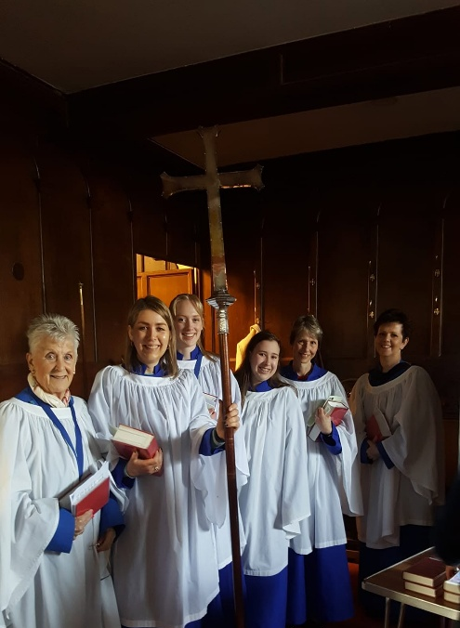
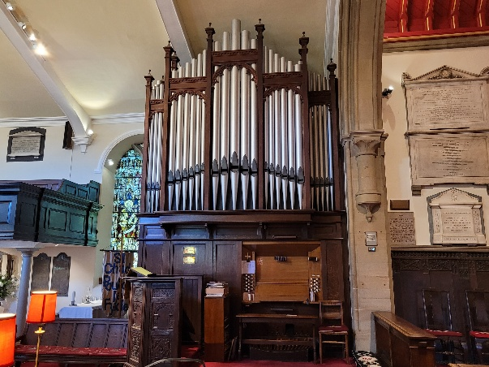
St Chad’s Church is seeking to appoint a skilled and enthusiastic Organist and Choir Leader to play for our worship at the 10am Sunday services and on special feast days throughout the year.
We are looking for someone who:
- brings musical excellence and joy to worship
- enjoys working collaboratively with clergy and congregation
- can train, nurture, and develop our friendly choir
- can help encourage a church-wide confidence in singing and music
This is a wonderful opportunity for a musician who loves church music, values community, and wants to help shape and inspire our worship life.
We have a two-manual pipe organ with pedal board and a Roland digital piano.
Remuneration will be £4200 per annum with additional fees paid for weddings and funerals.
If this sounds like you — or someone you know — please get in touch with St Chad’s. We’d love to hear from you!
For further details or to express interest, please contact: Revd Martin Keighley at martinkeighley@btconnect.com or 01253 883086.
All enquiries are warmly welcomed!

